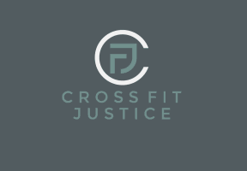
Strength Training Sessions for Swimmers
By CrossFit Justice

Where: CrossFit Justice
1280 Holden Ave #115, Milford, MI 48381
Cost: $15 /person
Time: 10:00 to 11:00 am
When: Saturday April 27th
What: 1 hour session: 15 min Education, 15 min mobilize and warm-up, 20 min strength and workout session, 10 min cool-down

Workout sessions to compliment your current swim training. Build up your strength without “bulking” up or feeling tired and sore. Come learn what you should be strengthening as a swimmer, get a great workout, and ask questions about how to implement these exercises on your own.

Sessions led by CrossFit Justice owner and head coach Chris Follick with 15+ years of running, marathon, swim, triathlon, personal training and CrossFit experience.

